

“Audio Library ”

Project Report submitted in partial fulfillment of the requirements for the award of the degree of

BATCHLOR’S OF COMPUTER APPLICATION (BCA)


Submitted By

Malvin Samuel Ashok

25BCYC39

Under the guidance of

Dr. K Kalaiselvi

SCHOOL OF COMPUTATIONAL AND PHYSICAL SCIENCES
DEPARTMENT OF COMPUTER SCIENCE
BCA/B.Sc PROGRAMME



DEPARTMENT OF COMPUTER SCIENCE

CERTIFICATE OF COMPLETION

This is to certify that the project entitled “Audio Library ” has been satisfactorily completed by 25BCYC39, Malvin Samuel Ashok in partial fulfillment of the award of the Bachelor of Computer Applications degree requirements prescribed by Kristu Jayanti [Deemed to be University] Bengaluru during the academic year 2025 -26.

Internal Guide Head of the Department

DECLARATION

I, Malvin Samuel Ashok holding registration 25BCYC39, hereby declare that the project work entitled ‘Audio Library ’ is an original project work carried out by me, under the guidance of Dr. K Kalaiselvi

Signature

Bengaluru

Date:
19 March 2026

TABLE OF CONTENTS

Sl. No | Topics | Pages
1 | Introduction | 5
2 | Tools and Technologies used | 6
3 | Modern Web Development Workflow | 7
4 | Screenshots | 8
5 | Conclusion | 9
6 | References

- Introduction:

The Audio Library is a simple web-based application developed as a hobby project to manage and play a collection of songs online. The primary objective of this project is to provide users with a lightweight and user-friendly platform where they can organize their personal music library efficiently. This application allows users to perform essential operations such as adding new songs, deleting existing ones, and playing audio files directly within the browser. It serves as a foundational project for understanding how media handling, database storage, and user interaction can be combined to build a functional digital music management system. It also follows the CRUD .

1.1 Features of the Audio Library:
- Add Songs
Users can upload or add new audio files to the library, enabling easy expansion of their music collection.
- Delete Songs
Songs can be removed from the library at any time, allowing users to manage and clean up their collection efficiently.
- Play Audio Online
The application includes an integrated audio player that allows users to play songs directly within the browser without downloading them.
- Song Collection Management
Displays a list of all added songs, making it easy to browse and select tracks.
- Real-Time Playback Controls
Includes controls such as play, pause, and seek to enhance the listening experience.

2. Tools and Technologies
  - Frontend (UI Layer):
- HTML
Used to make the structure of the website like the player , layout and sidebar.
- CSS
It is used to design or style the website to make the user-interface look more attractive.
- JavaScript
It is used to provide logic to the different features required in the operation of the website
Ex: 1.The play/pause button ,which is used for the audio control.
2.Fetching the audio from the database.

  - Backend (Server):
It works on the API logic and maintain the server.

- Nodejs:
It is a runtime environment that executes JavaScript on the server side that handles the logic required , enabling backend development and API creation.
- Vercel serverless function:
It is a function that Vercel provides that helps to run the server based functions when it is required while not having to manage the servers.
Ex : The logic to fetch ,add and delete the songs from the database.

  - Database :
- Supabase:
It is a Backend-as-a-Service that provides a PostgreSQL database and auto generated APIs to store and manage application data without building a custom backend.
Stores all song data in :
  - Title
  - Artist
  - file (audio URL)
  - cover image
  - lyrics

3. Modern Web Development Workflow

My project follows a modern web development workflow where the frontend is built using HTML, CSS, and JavaScript, the backend is implemented using Node.js serverless functions deployed on Vercel, and the database is managed using Supabase (PostgreSQL). Version control is handled through GitHub, and deployment is automated via Vercel’s CI/CD pipeline. The application is hosted online and accessed through a web browser which enables the users to interact with the audio library system efficiently.

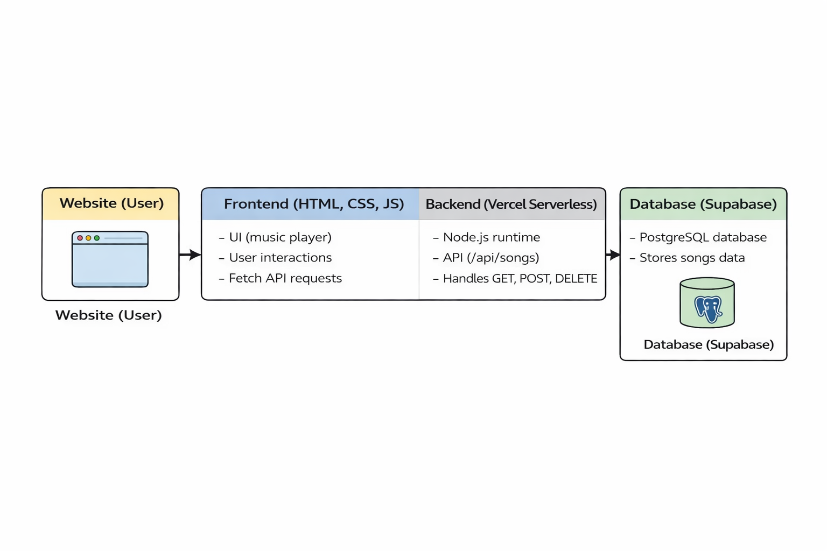

Figure 1

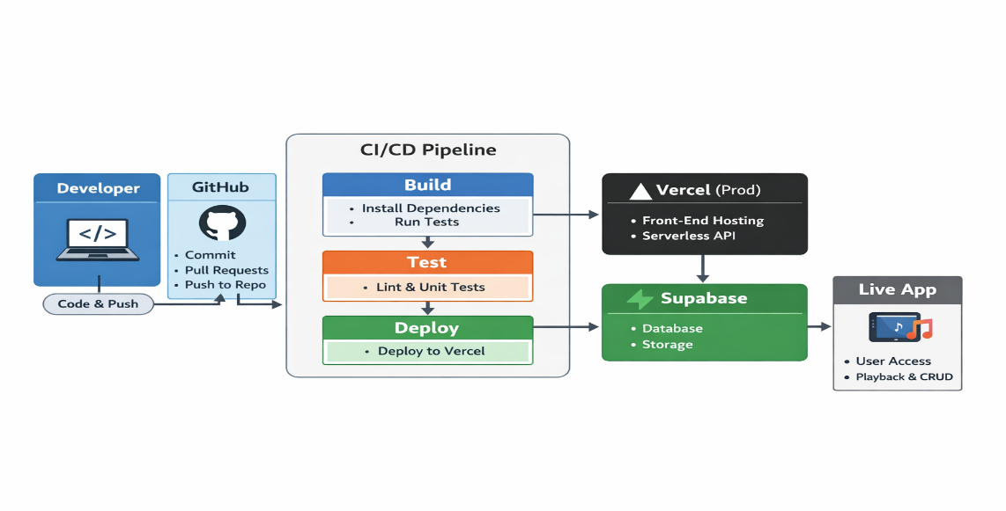

Figure 2
Figure 3: UI (Front-end)

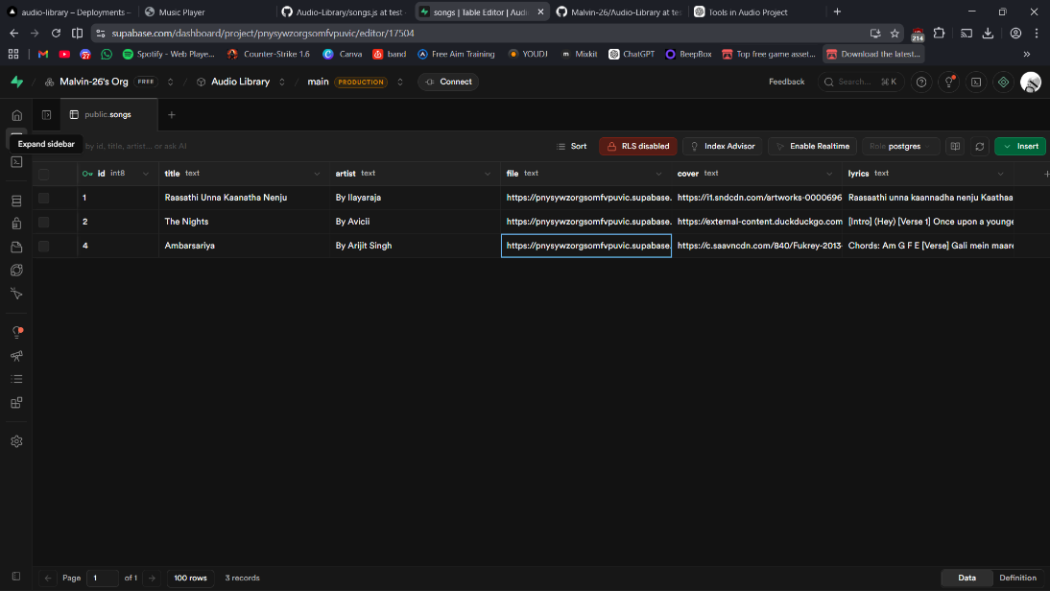
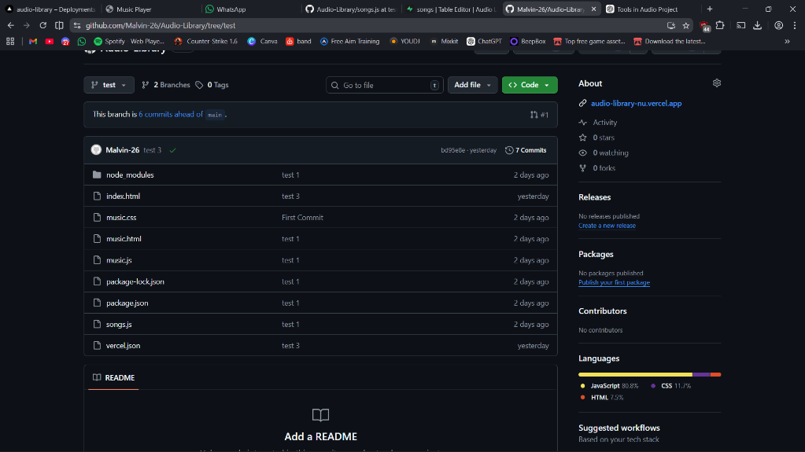
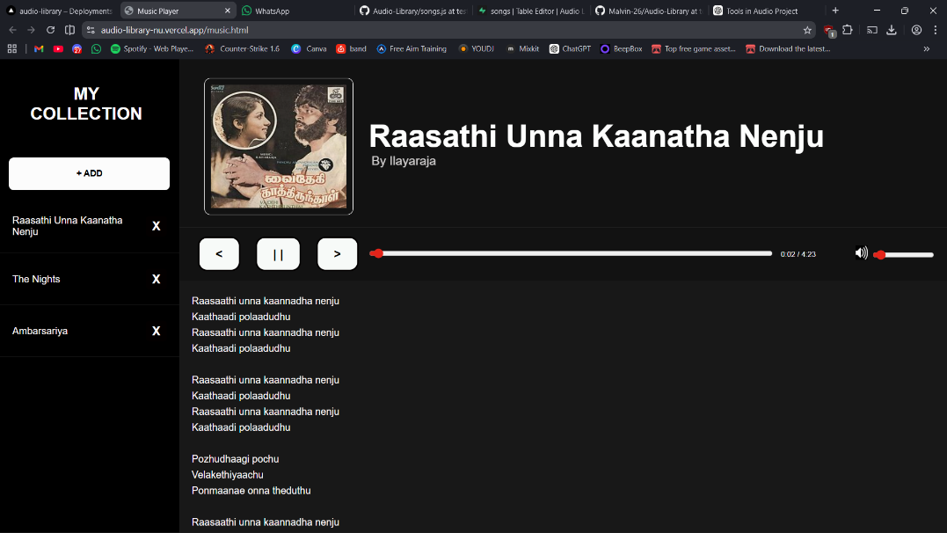
Figure 5: Supabase(Database)
Figure 4: Github Repository

5. Conclusion:

The Audio Library project shows how a modern web application can be built by combining different technologies such as frontend design, backend processing, and database management. In this project, the user interface allows users to add, delete, and play songs easily, while the backend handles storing and retrieving song data efficiently. This demonstrates how different parts of a web application work together to create a smooth and functional system.

Working on this project helped in understanding important web development concepts such as how data is sent and received, how user interactions are handled, and how applications are deployed. It also improved problem-solving skills and provided practical experience in building a real-world application.
Moreover, this project provides a good base for future improvements. One important enhancement could be adding an AI-based feature that can automatically fetch song details. In the future, the user may only need to enter the song title and artist name, and the system can automatically add the cover image, lyrics, and audio. This would reduce manual work and make the application more efficient and user-friendly.

In conclusion, the Audio Library project successfully achieves its goal of building a functional music application and also opens up opportunities for further development using advanced technologies like artificial intelligence.

